Report on the implementation of the Route Recommender Algorithm.

I. The implementation
As I understand, the current application has no features regarding the users and his actions. So in order to implement the algorithm, I created the necessary classes for it to work. Right now every thing is generated randomly. For example, when a user is created, his profile and his rates on different location is also generated randomly.

II. How does the program work
After the calculation of the route, the program applies the algorithm on the list of route that was calculated.
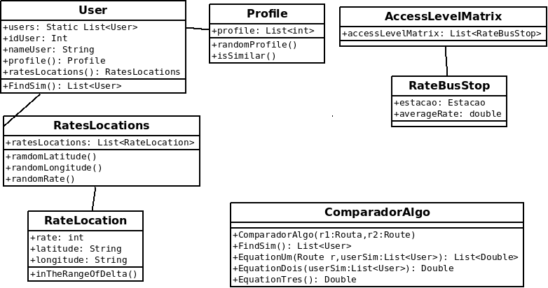
2.1: Class Diagram

The diagram above represent some of the different classes that was implemented for the algorithm.

The user class : It has an id, a name and other values that represent the user personal information. What is important in this class is the profile and the list of rate that the user create.
The profile class : A profile is array of zero and one that represent the user disability.

2.2 : Example of profile

For example the array above represent the profile of a visual impaired person. For a person on a wheel chair it would be [1|0|0]. In the current application the profile is generated randomly.
The RateLocations class : It contains all the rate a user made for a location. The rate is between 1 and 3. Right now the rates are generated randomly as well. It takes a bus station and give random rate to a location around delta meters of the bus stop.
The RateLocation class : It his a rate for a location. So you give it a latitude and longitude and a rate.
The AccessLevelMatrix class : It his the access level matrix for each bus stop. It his calculated with the users votes. We look in a delta range to see if you have a users votes, and then we calculated the average rate of a bus stop.
The RateBusStop : It is a average value of the accessibility level of a bus stop.
The ComparadorAlgo class : It is the most important class in the system. Here are implemented the three equation in the algorithm. So this class applies the algorithm on the list of route that is given to him.

III. Problems
In the current application some stops are missing. So when a route is created and it contains stops that are not in the database, we put a zero in the accessibility level matrix for this bus stop. So it is consider has a place without any rates yet.

IV. Test
For the test we had nine users in the system. One was the reference user. That means that to apply the algorithm we are going to take a look at his profile and his rates. In the list of similitude we have 3 users from the eight remaining. In the array below we can see the similarity cosines between the reference user and each user in the similitude list.

3.1 : User in the similitude list

For the test we enter the path from Bigorrilho - Rua Marechal José Bernardino Bormann, Curitiba - State of Paraná, Brazil to Rua dos Coqueiros - Bairro Alto, Curitiba - State of Paraná, Brazil. In the application the stops that could be find are the following. With them you can see the accessibility level and the usefulness of the stop

3.2 : Stop in the route the accessibility level and usefulness

In the array above we can see some zero. It is because we have not find vote in the access level matrix for the location. The equation 3 is the usefulness of the stop.
3.4 : Route with their bus stop

In the array above you have the constitution the route. Some route contain bus stop with no information as explain in the problems.

3.5 : Route usefulness and time of the travel
3.6 : Chart of the usefulness of the route
As you can see the best route is route 6 with 49 minutes follow by route 3 with 50 minutes.

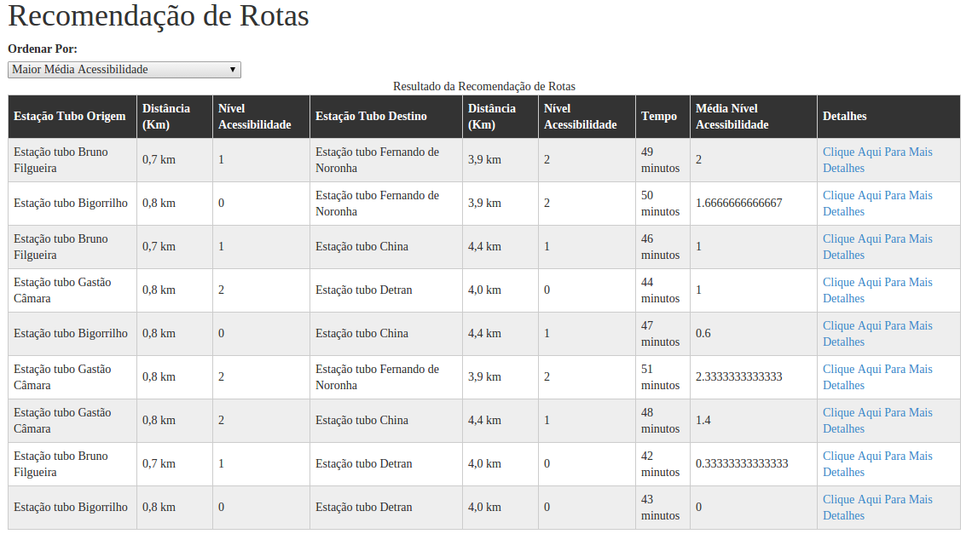
3.7 : Screen-shot of the application with the route proposal

Conclusion
The algorithm seems to be working. I conduct different test to see if it is true, but other people have to test it before we are 100 % sure. With this document I enclose logs and excel file with different result that can help understand the implementation and how it works. I also commented the code so that it will be easier if modification is needed in the future.

